LED Lanterns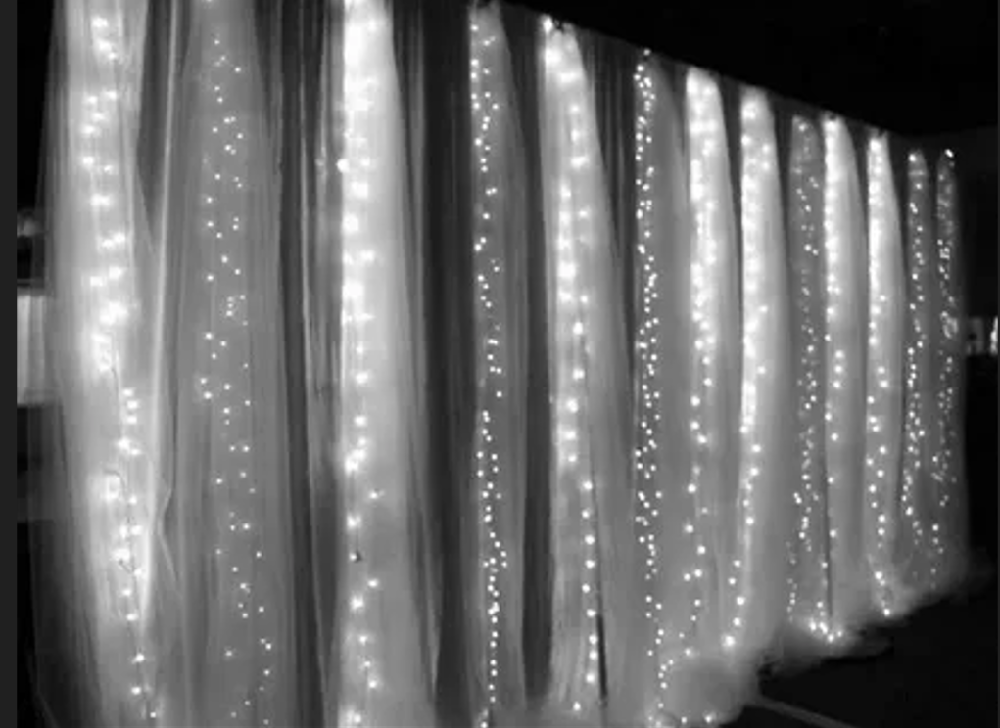

#### ****Description:****

**LED Lanterns** are versatile, energy-efficient lighting solutions designed to provide portable and decorative light for both indoor and outdoor use. These lanterns are perfect for creating a cozy and inviting atmosphere at parties, camping trips, and home decor. With their durable design and multiple lighting modes, LED Lanterns offer both functionality and style.

* **Technology:** LED.
* **Power Source:** Battery-operated (typically AA or rechargeable batteries).
* **Bulb Type:** Integrated LED (non-replaceable).
* **Wattage:** 3W (equivalent to 30W incandescent).
* **Lumens:** 200 lumens.
* **Color Options:** Warm white, cool white, multicolor.
* **Dimmable:** Yes (select models).
* **Lifespan:** 50,000 hours.
* **Energy Efficiency:** Energy-efficient LED technology.
* **Weather Resistance:** IP44 rated (splash-proof for outdoor use).

#### ****Key Features:****

* **Portable Design:** Lightweight and easy to carry, making them perfect for camping and outdoor events.
* **Energy-Efficient:** Uses LED technology for long-lasting and energy-saving performance.
* **Multiple Lighting Modes:** Adjustable brightness and color options for customizable lighting.
* **Durable Construction:** Built to withstand outdoor conditions and rough handling.
* **Easy to Use:** Simple controls for turning on/off and adjusting settings.
* **Versatile Use:** Suitable for indoor and outdoor settings, including parties, camping, and home decor.

#### ****Pricing:****

* **Single LED Lantern (Warm White):** $19.99
* **Single LED Lantern (Multicolor):** $24.99
* **2-Pack LED Lanterns (Warm White):** 34.99(34.99(17.50 per lantern)
* **2-Pack LED Lanterns (Multicolor):** 44.99(44.99(22.50 per lantern)

#### ****Where to Use:****

* **Camping:** Provide reliable and portable lighting for outdoor adventures.
* **Parties:** Add a festive touch to indoor and outdoor celebrations.
* **Home Decor:** Enhance living rooms, patios, and balconies with cozy lighting.
* **Emergency Preparedness:** Use as a reliable light source during power outages.
* **Outdoor Events:** Illuminate gardens, pathways, and outdoor gatherings.

### ****Customer Reviews:****

* ⭐⭐⭐⭐⭐ "These LED Lanterns are fantastic! They provide bright, reliable light, and the multiple lighting modes are perfect for creating the right ambiance." – Sarah L.
* ⭐⭐⭐⭐ "Great value for the price. The lanterns are durable, and the battery life is impressive. Highly recommend for camping and outdoor use." – James T.
* ⭐⭐⭐⭐⭐ "I love how energy-efficient these lanterns are. The warm white glow is perfect for creating a cozy atmosphere at home." – Emily R.

### ****How to Order:****

1. Visit our website: [www.brightworldlighting.com](http://www.brightworldlighting.com/)
2. Select your preferred color option and pack size (Single or 2-Pack).
3. Add to cart and proceed to checkout.
4. Enjoy free shipping on all orders over $50!

### ****Warranty and Support:****

* **Warranty:** 1-year limited warranty covering manufacturing defects.
* **Customer Support:** Contact us at [support@brightworldlighting.com](mailto:support@brightworldlighting.com) or call +1-800-123-4567 for assistance.

### ****Visual Representation:****

Include high-quality images of the LED Lanterns in different settings (e.g., camping, home decor) to showcase their versatility and design.